Name: _______________________________________________ Date: _________________

Math Test

Directions: Listen to the amount of money said by the teacher. Write the amount.

1. ______________________________
2. ______________________________
3. ______________________________
4. ______________________________
5. ______________________________

Directions: Write the amount of money in each set.

1. 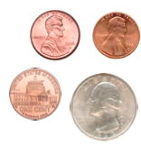 ______________________
2. 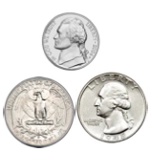______________________
3. 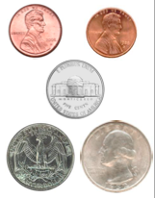 ______________________
4. 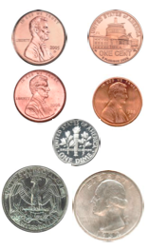______________________
5. 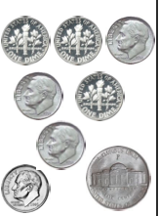______________________
6. 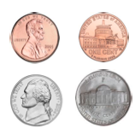______________________
7. 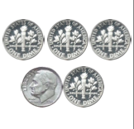______________________
8. 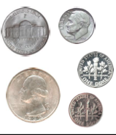______________________

Directions: Get the correct amount of money for each amount. Put in a baggie labeled 14 and 15 and hand in with your test.

14.

15.